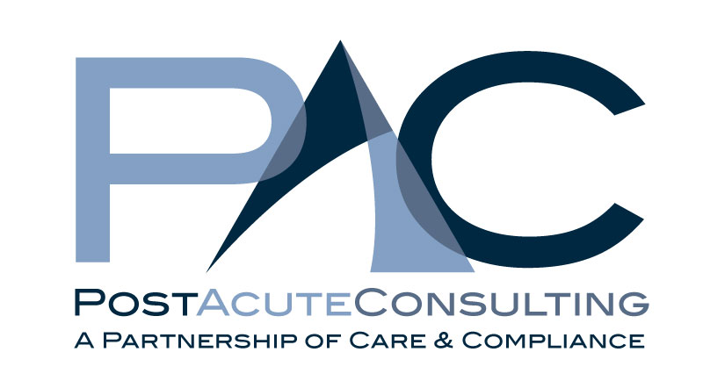

Regional Clinical Reimbursement Consultant

Post Acute Consulting provides their clients with the most up to date information needed to drive their centers financial security and quality of care within the ever changing Medicare and Medicaid reimbursement environment.

The challenges of changing regulations and the government efforts to tighten the belt have made the role of an MDS RN even more specialized. Many have left the profession and the talent pool for this role is shrinking. These are exciting times for the rare individuals who have found their passion in the health care industry within LTC and Reimbursement.

Consulting is the next career expanding step for your talents. Now is the time to branch out and bring your talents to the centers that need them the most. Smaller multi center companies, stand alone centers without regional or corporate support services of their own will benefit immediately from your assistance. Take the experience and knowledge you have and package it with customer service and proven tools to bring a level of support to our client base that other firms cannot.

We are growing our team of experts and are conducting a search for a Regional Clinical Reimbursement Consultant.

The ideal candidate will have an extensive back ground in multi facility responsibilities and proven knowledge of successful strategies and regulatory compliance. This role requires a Registered Nurse with vast knowledge of the MDS/RAI process and the ability to assess a client’s culture and individual needs. The successful candidate will be skilled in the development of relationships with each clients interdisciplinary team; improving communications, systems and outcomes.

The Clinical Reimbursement Consultant assures the management of the Medicare, Medicaid, managed care and case mix reimbursement for PAC client facilities.

- Medicare Medicaid Systems Audit
- Assessment of current process and compliance accuracy
- In-Service training development and delivery
- Liaison to the communication process between disciplines
- Department (staffing)Organization assessment and recommendations
- Total process assessment and recommendations, May include Culture Change Initiatives.
- Conduct weekly, monthly, quarterly on site visits as well as conference calls for follow up and on-going support.
- Managing length of stay
- Participate in marketing efforts to grow our client base.
- Respond to Hotline Support calls
- Over night travel is required between client facilities

You will be responsible for regulatory compliance and quality improvement efforts to ensure that the facilities maximize the reimbursement to which they are entitled. You will serve as a role model for ethical business practices for assigned facilities and work to ensure that the services offered exceed PAC and client quality standards as well as federal and state regulations.

